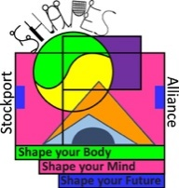

Athletics Festival
Equipment per child
10 cones
1 foam javelin
5 Hurdles/ sets of 3 cones to make one hurdle
3 hoops
3 bean bags/shuttlecocks

- Each pupil to keep the same set of equipment to themselves and find their own space in the playground/hall.
- Each pupil sets up their own equipment as per the stations and keeps their own score on their own scorecard
- Teacher to supervise and time the 2 minutes for the children when they are attempting the timed part of the challenge. Prior to this give them time to practice the challenge first.
- At the end of the session, each child to wipe their own equipment with antiseptic wipes before putting it away and then wash their hands

Station 1 – Shuttle Sprint

Setting up
- Place 2 cones about 20m away from each other/20 large strides or between 2 lines on the playground.
- Keep your cones 2m away from other people’s cones.

Activity
- Stand behind a cone facing the other cone.
- Run to the cone, around it and then back to the cone you started at.
- How many times can you do this in 2 minutes?
- Write your score on your card – there and back is 1 point

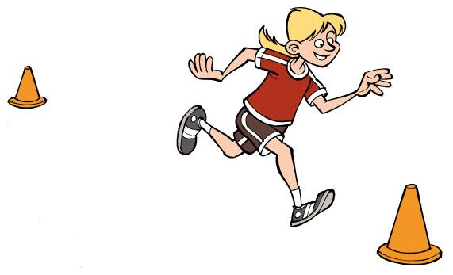

Station 2 – Standing long Jump

Setting up
- Place a cone 1m/1 big stride away from a line on the playground.
- Then place another 9 cones in a line going away from the line on the playground.
- Keep your equipment 2m away from other people’s.

Activity
- Place your feet up to the line, bend your knees and swing your arms to jump as far as you can.
- Points are scored depending on which number cone your heels land next to. For example, the 6th cone = 6 points. Have 3 jumps.
- To challenge yourself to try to jump further each time.
- Write your total score after 3 jumps on your card.

9
8
7
6
5
4
3
1
2

Jump line X = 6 POINTS

Station 3 – Foam Javelin

Setting up
- Place a cone 1m/1 big stride away from a line on the playground.
- Then place another 9cones 2m/2 big strides apart in a line going away from the line on the playground.
- Keep your equipment 2m away from other people’s.

Activity
- Stand sideways on with the javelin/beanbag in one hand held straight out behind you.
- Throw the javelin/beanbag as far as you can.
- Points are scored depending on which number cone your javelin lands next to. For example, the 4th cone = 4 points. Have 3 throws.
- Write your total score after 3 throws on your card.

5
6
4
3
2
1

X = 4 POINTS

Station 4 – Hurdle Sprint

Setting up
- Set 5 hurdles/ 3 cones next to each other to make one hurdle (15 cones makes 5 hurdles) out within a 10-metre space.
- Keep your hurdles 2m away from other people’s.

Activity
- Run over all of the hurdles and then sprint back to the start down the side of the hurdles.
- You must only run one way over the hurdles.
- How many times can you do this in 2 minutes
- Write your score on your card. Running over the hurdles and then running back is 1 point.

10 Metres

Station 5 – Bean Bag Target Throw

Setting up
- Place 3 hoops in a line 5 metres away from a line on the playground.
- Keep your hoops 2m away from other people’s.

Activity
- Stand at the line with the first bean bag.
- Throw the bean bag underarm, aiming to get it to land in the hoops.
- If the bean bag lands in 1st hoop = 1 pt, 2nd hoop = 2 pts, 3rd hoop = 3pts
- Repeat for two more bean bags.
- Write your score for all 3 bean bags on your card.
- To make it easier, make your throwing line closer to the hoops/to make it more challenging make your throwing line further away from your hoops. In the absence of hoops use a line of cones to throw past.

Throw line
1

3
2

Station 6 – Stamina Run

Setting up
- Set up a course around an area of the playground with your 10 cones that measures around 50 metres/50 large strides altogether.
- Keep your course at least 2m away from other people’s stations.

Activity
- Run around the outside of the course. Every time you complete a lap you get 1 point.
- How many laps can you do in 2 minutes?
- Write your score on your card.

Name ……………………………………………Class ……………………..
Activity | Score 1 | Score 2 | Score 3
Shuttle sprint
Standing long jump
Javelin (throwing for distance)
Hurdle Sprint
Bean Bag target throw (throwing for accuracy)
Stamina Run
TOTAL

